Deer Hill School News
October 3, 2014

Important Dates:

Oct. 3 Yom Kippur begins at sundown
Oct. 7 SEPAC, Paul Pratt Library
Oct. 10 Professional Development Day, no school
Oct. 13 Columbus Day, no school
Oct. 14 Specialist Open House (adults only please)
Oct. 15 Daffodil Day, 3:00 pm
Oct. 22 Early Release Day, 12:40 (Conferences)
Oct. 23 Early Release Day, 12:40
(Conferences)

BACK TO SCHOOL NIGHT,
PART II!
On Tuesday night, October 14, beginning at 6:30, our specialist teachers will host their own Back to School Night! This is in response to our spring Parent and Guardian Survey results, which told us that families would like to learn more about the specialist curriculum in the areas of Art, Music, Physical Education, Computers, and Health. So our specialist teachers have planned presentations of their own! 6:30 to 7:30 pm Adults only please.

International Walk to School Day October 8th.

All students and families are invited to join us as we walk to school on Wednesday, October 8th. Lots of teachers will be walking to school too on that day. We will leave from the Pratt Library around 8:00 – 8:10.
If you’ve not already done so, please send in a picture of your child for the picture board in Dr. deChiara’s office.
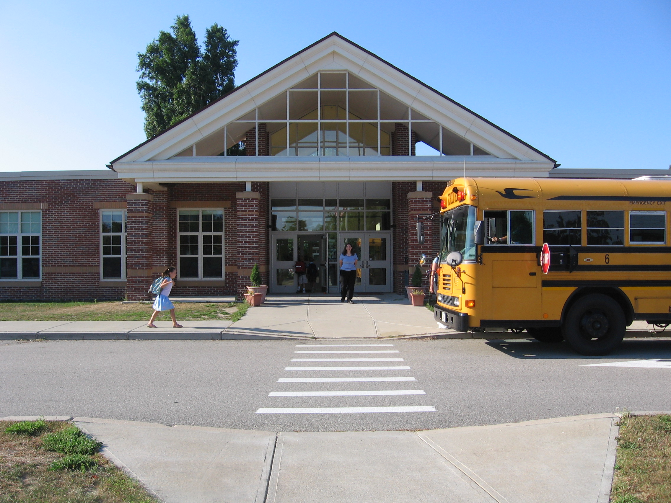
Daffodil Day
Please join us on Wednesday, October 15th, for our 8th Annual Daffodil Day. We will meet outside the front of the school at 3:00 to plant 100 daffodil bulbs. (Many hands make light work!) Bulbs are provided, but helpers – both students and adults – are encouraged to bring their own garden gloves and small shovels.

Have you heard the buzz?
The CEF 7th Annual Spelling Bee is coming early this year! Save the date- SUNDAY, 11/16 at the Middle/High School, 12:30-5p (different heats for each grade). And guess what’s new? HIVES OF TWO- so 3rd, 4th & 5th graders don’t BEE left out. Pick a partner, BEEcome a team & BEE the HIVE that SURVIVES!
More info to come…

Special Education Parent Advisory Committee (SEPAC) EVENTS
“BASIC RIGHTS”
SEPAC speaker, Mary Buchanan, Director of Student Services
Tuesday, October 7th, 7 – 8:30 pm
Paul Pratt Library, Community Room

“ORGANIZE YOURSELF”
Parent to Parent Support Coffee,
October 15th, 11:00 – 1:00 pm, Home of Co-Chair, Diane Herth, 100 Pond Street, Unit #39

Presented by the Cohasset SEPAC Board. We will show you how to organize your child’s education information in binders with tables and information necessary. Pre-order 2” binder (for each grade), $10 with pre-labeled tabs and helpful information gathered to coach you to gather and keep your child’s IEP and 504 information in order and easily accessible. If you prefer to check it out first and have us deliver the completed binder within 48 hours, we can do that for you. Babies are welcome!

For more information regarding Cohasset SEPAC, please visit our website at www.CohassetSEPAC.org. As always, the meeting is free and open to the public.

2014-2015 A+ School Rewards Program: Deer Hill School supporters do not need to re-register their Stop and Shop Card anymore. This program allows us to receive a percentage of expenditures made by our supporters at the Cohasset Stop and Shop. Proceeds go to the Deer Hill PSO. If you need to sign up, go to the above website. Our ID number is 06903. www.stopandshop.com/aplus.

Safe Drop Off: AM drop off should occur in the back of the building, at the door next to the gymnasium. That door is supervised from 8:20 to 8:30, and then locked at 8:30. If you need to drop off your child at the front of the building before 8:30, please park your car and walk your child across the bus lane. It is too dangerous to let students cross through the buses without parental supervision and cars are not allowed in the bus lane before 8:30.

On Sunday, October 5 from 2-4 pm the Cohasset Historical Society and Cohasset Historical Commission will host a reception to recognize the many students who contributed projects for the Capt John Smith exhibit currently on display. The students and their families will have the opportunity to view the exhibit. Also as part of the exhibit are items from the Society’s collection and early Native American artifacts found in Cohasset. The Cohasset Historical Society is located at 106 So Main Street. For more information please call the society at 781-383-1434.

DEER HILL PSO

We were delighted to meet and welcome new families at the New Family Coffee morning on Wednesday October 1st. We typically hold a PSO meeting on the 1st Thursday of every month at 9.30am in the school cafeteria. Our next meeting will be held on Thursday November 6th.

Calling all Coupon Books! If you have not returned your coupon book or payment, please do so as soon as possible. The coupon books cost $25 and you can make a check out to Cohasset PSO. If you do not want the book, simply send it back to your child's teacher. If you ordered additional books, we are working on getting them to you. Any questions or concerns can be directed to Sue Shepherd at 917-748-0329.

Coming up – the PSO Fruit Sale Fundraiser begins on October 24th. More information regarding this will follow closer to the date.

PSO Holiday Boutique: We are putting together the vendor list for our PSO Holiday Boutique that will take place on Saturday, November 15th at Deer Hill. If you, or someone you know, has a home business or makes items for sale, we would love to have you participate in the boutique. In the coming weeks, we'll be asking for volunteers to help out at the boutique and to bake for the PSO Bake Sale table. For more information, please contact Mary Fran Olson at maryfranolson@gmail.com

Reminder: Students should arrive at school between 8:20 and 8:30 am. We are not able to provide supervision prior to that time period.

